Django backend developer with experience for PHP.

I need help creating "Dynamic" headers for a checklist in Django. I have a little experience with Django and python but I need both guidance and the code to complete the list.

**The use case:**

1. As a user, I want to create a task with a category.

**Example task creation with dropdown for category**

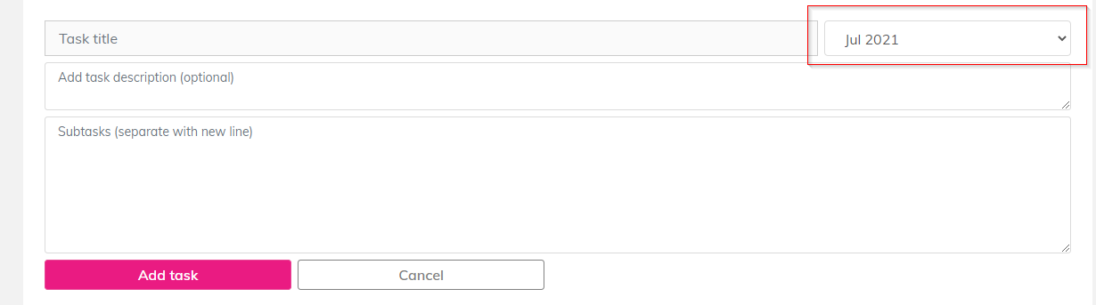

**Example checklist**

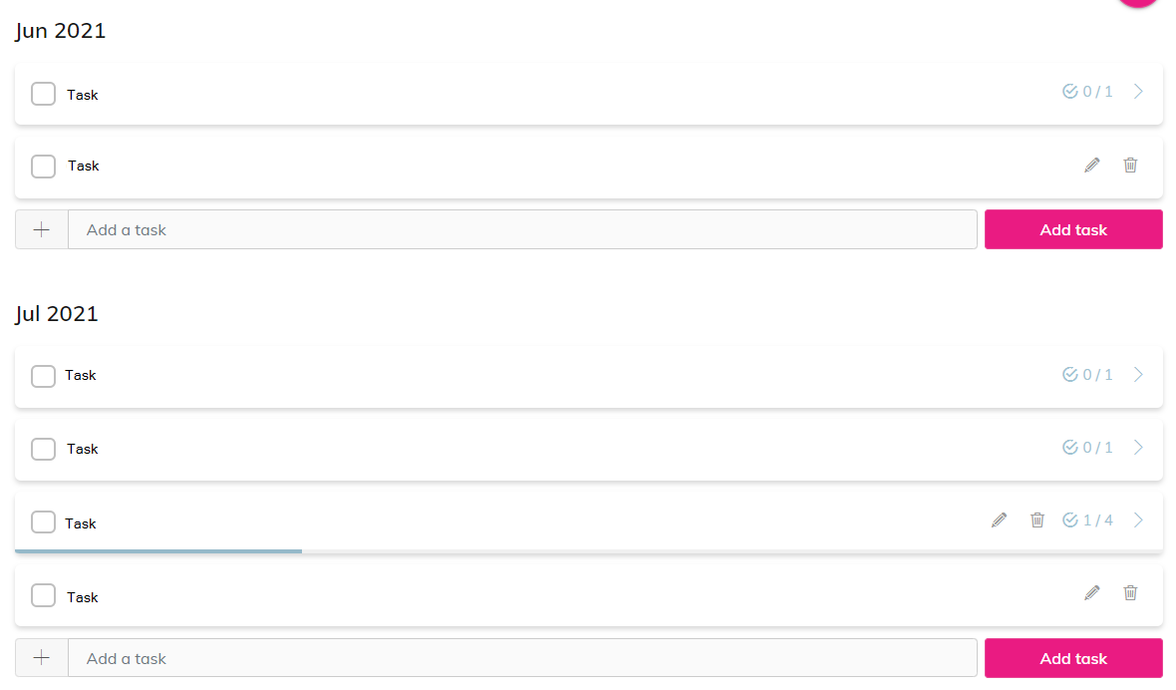

# Example for a wedding in September 2021

**January 2021**

1. Task
2. Task

**Februrary 2021**

1. Task
2. Task

**March 2021**

**April 2021**

**May 2021**

**3 month to wedding**

**1 month to wedding**

**1 week to wedding**

**Wedding Day**

**After Wedding**

* Task
* Task

This category partially consists of static categories that is coded (see below and in the above example) and dynamic headers that are generated by two dates.

Static headers (they will get translated later) in Django

def get_task_category(self) -> list:

    wedding_date = datetime(2022, 1, 1)

    task_startdate = datetime(2022, 1, 1)

    task_category = [_('After wedding'),

                    _('Wedding day'),

                    _('1 week to go'),

                    _('1 month to go'),

                    _('3 months to go'), ]

    ... code to generate dynamic headers.

    return task_category

**ERD:**

# 

# My thoughts:

I want to create a function (get_task_category) to return the headers, when the user want to create a new task. Im not sure if this function should be in the model (outside task model), or if it should be in a model manager. That means, the list is related to the checklist Model and from the model to the user.

The dynamic categories should be generated based on some logic (see PHP code below) so when the user creates the task, there will be a dropdown with categories.

**What I tried so far:**

Created a Checklist and Task model:

class Task(models.Model):

    task_category = models.CharField(verbose_name="task category",

                                   #    choices=get_task_category,

                                   max_length=100,

                                   null=True,

                                   blank=True)

    name = models.CharField(_("task name"), max_length=255)

    description = models.TextField(

        _("task description"), null=True, blank=True)

A function, but it doesn’t work as intended.

num_months = (wedding_end_date.year - task_start_date.year) * \

    12 + (wedding_end_date.month - task_start_date.month)

num_months = num_months + num_of_year

categories = ['After wedding', 'Wedding day', '1 week to go',

              '1 month to go', '3 months to go']

dynamic_length = 2 if num_months < 3 else (

    12 if num_months > 15 else num_months - 3)

i = 1

while i <= dynamic_length:

    m = i + 3

    print(m)

    # categories.append(datetime(wedding_end_date.year, m, 1).strftime("%B %Y"))

    i += 1

In general, I need guidance on design principle, what I did wrong and the code in Django to help me continue my work.

**PHP (wordpress)**

public function get_wedding_categories( int $user_id = 0 )

    {

        if ( get_userdata( $user_id ) == false ) return new WP_Error( 'no_user', __( 'No user.', 'bryllup' ) );

        $wedding_date           = get_user_meta($user_id, $this->get_option('wedding_date_key'), true);

        $wedding_date_timestamp = empty( $wedding_date ) ? 0 : strtotime( $wedding_date );

        $wedding_date_set_on    = get_user_meta($user_id, 'wedding_date_set_on', true);

        $wedding_date_set_on    = empty( $wedding_date_set_on ) ? 0 : $wedding_date_set_on;

        $has_wedding_date       = empty( $wedding_date_timestamp ) ? false : true;

        if ( ! $has_wedding_date ) return new WP_Error( 'no_wedding_date', __( 'No wedding date set.', 'bryllup' ) );

        $start              = new \DateTime( date('Y-m-d H:i:s', $wedding_date_set_on ) );

        $end                = new \DateTime( date('Y-m-d H:i:s', $wedding_date_timestamp ) );

        $days               = $end->diff($start)->format('%a');

        $months             = $end->diff($start)->m + ($end->diff($start)->y * 12);

        $dynamic_length     = $months < 3 ? 2 : ( $months > 15 ? 12 : $months - 3 );

        try {

            $categories = [

                __( 'After wedding', 'bryllup' ),

                __( 'Wedding day', 'bryllup' ),

                __( '1 week to go', 'bryllup' ),

                __( '1 month to go', 'bryllup' ),

                __( '3 months to go', 'bryllup' ),

            ];

            for( $i = 1; $i <= $dynamic_length; $i++ ) {

                $m = $i + 3;

                $categories[] = ucfirst( date_i18n( 'F Y', strtotime( "-$m months", $wedding_date_timestamp ) ) );

            }

            $month_year = date_i18n( 'F Y' );

            $categories = array_map( function ( $cat_id, $cat ) use ( $month_year ) {

                $cat = $cat ?? __( 'Older', 'bryllup' );

                $selected = strtolower( $month_year ) == strtolower( $cat );

                return [

                    'id'        => $cat_id,

                    'label'     => $cat,

                    'title'     => sanitize_title( $cat ),

                    'selected'  => $selected,

                ];

            }, array_keys( $categories ), $categories );

            return $categories;

        } catch (Exception $e) {

            return new WP_Error( 'wedding_date_timestamp', $e->get_error_message() );

        }

    }